University Domination
Game Manual

TABLE OF CONTENTS

Objective of the Game..…………………………………………………………………………….2

Main Menu…...……………………………………………………………………………………….3

Basic Game Elements..…………………………………………………………………………….4

In Game User Interface HUD………………………………….…………………………..……….5

Gameplay….………………………………………………………………………………………….7

Minigame….………………………………………………………………………………….……….9

Controls…....…………………………………………………………………………….………….10

Objective of the Game

In a not so distant future the University of York has been completely taken over by the students.
The campus was split into thirty-two sectors under the control of the four main student gangs.
However, given the extreme instability of the situation, conflicts soon started and eventually lead to an all out, (non-violent) war between the gangs.

Now it’s your time to step in! In order to achieve victory you must be the last player standing. Eliminate other players by capturing their territory and destroying their units.

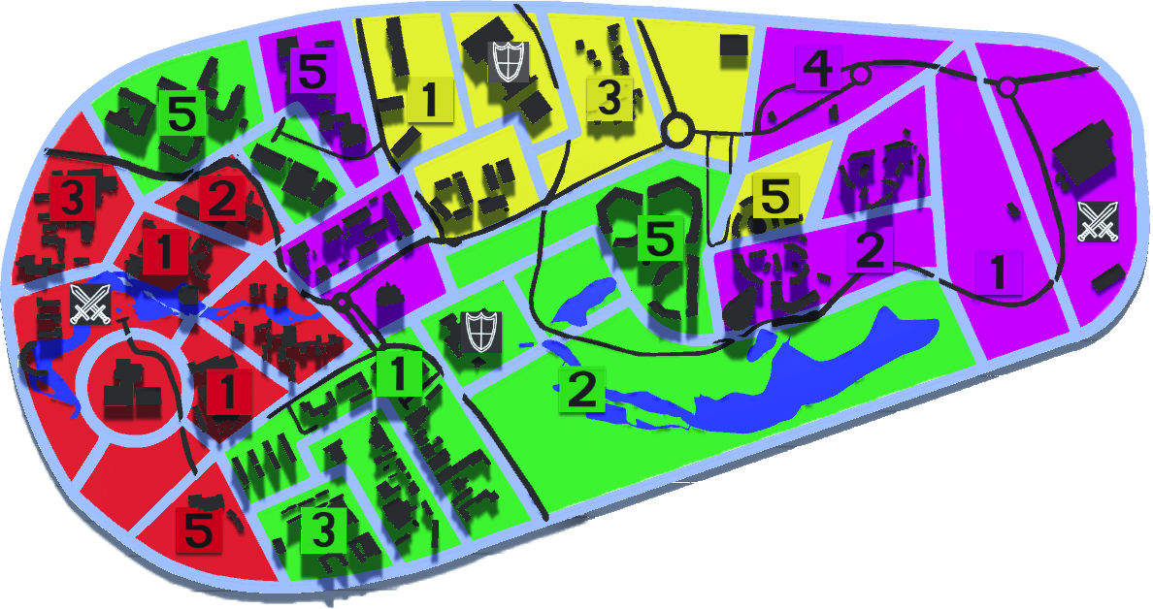
Main Menu

When you launch the game you will enter the Main Menu, use it to start a New Game or Load the last saved game.
If you decide to start a new game, you will be asked to choose the gamemode to play.

The available game modes are:
- “3 Players”, three players are controlled by humans whilst the fourth one is a Neutral Player controlled by A.I.
- “4 Players”, all four player are controlled by humans
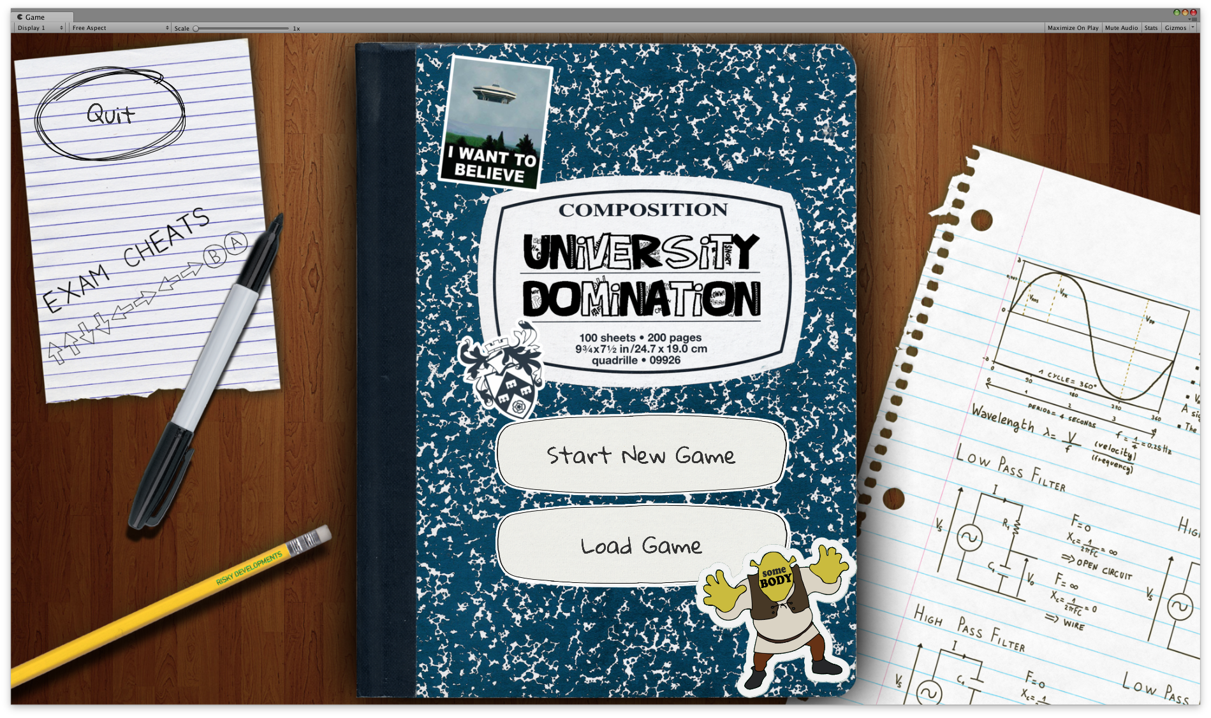
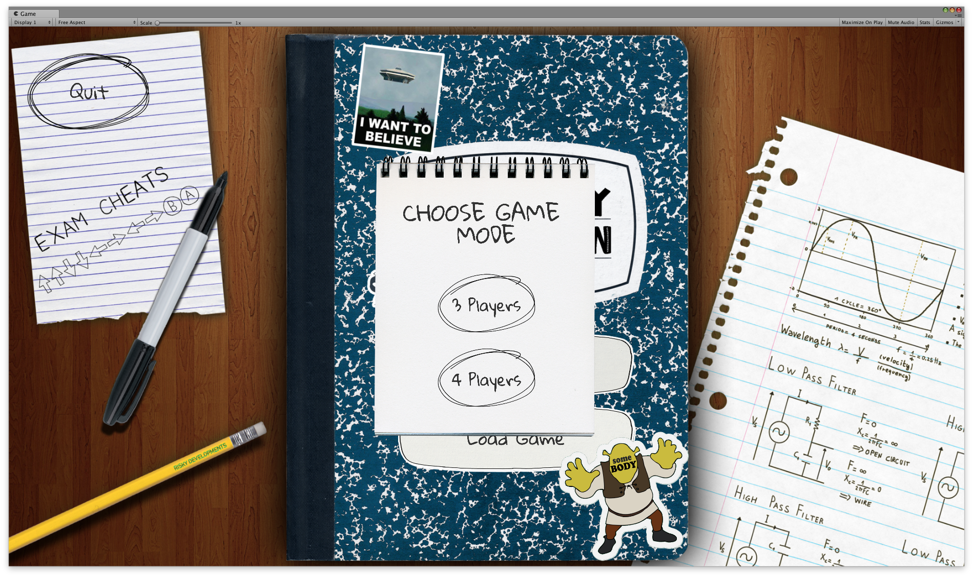
Basic Game Elements

Map
The map is divided into 32 sectors, 4 of which are landmarks. A sector may be owned by at most 1 player, and it may contain at most 1 unit.


Landmarks
A landmark is a special kind of sector. If a player owns a landmark, a new unit will spawn on the landmark at the start of the player’s turn, assuming there is not a unit already on the landmark.

In addition, each landmark is associated with a specific type of perk, and the player who owns the landmark also owns +2 of the landmark’s associated perk.
The icons representing the two kinds of landmarks are displayed on the right, defence is at the top and attack the lower one.

Units
Units are a player’s instrument with which to capture sectors and eliminate other players. New units spawn at Level 1, and may progress up to Level 5. Each time a unit successfully captures a sector, its level increases by 1. A unit’s level determines its overall strength - a higher-level unit is more likely to win conflicts with other units.

Perks
There are two types of perks: Attack and Defense. Attack boosts a player’s offensive power, while Defense boosts a player’s defensive power.

In Game User Interface HUD

The in game user interface consists of 4 components: Player Status Cards, End Turn Button, Actions Label, Menu Button.

Player Status Cards
Placed below the map, they display important information about each player such as the amount of perks owned and the percentage of the map under each player’s control. If the Neutral Player is present it will replace Player 4.
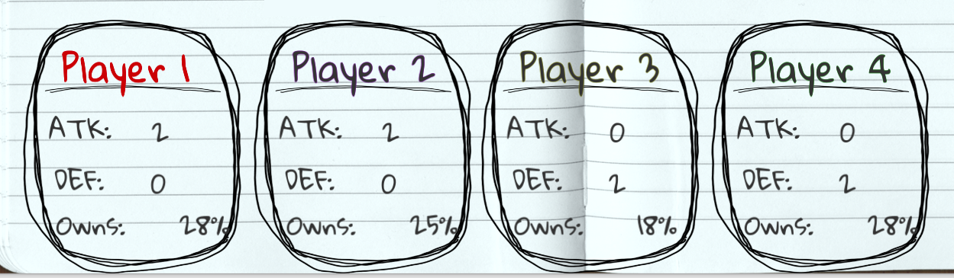
Additionally, the colored player label indicates who is playing during a given turn.

End Turn Button
Placed in the bottom right corner, it is used to pass the turn.

Actions Label
Placed to the right of the map and above the player cards, it displays the number of remaining actions that the player can still perform in the current turn.
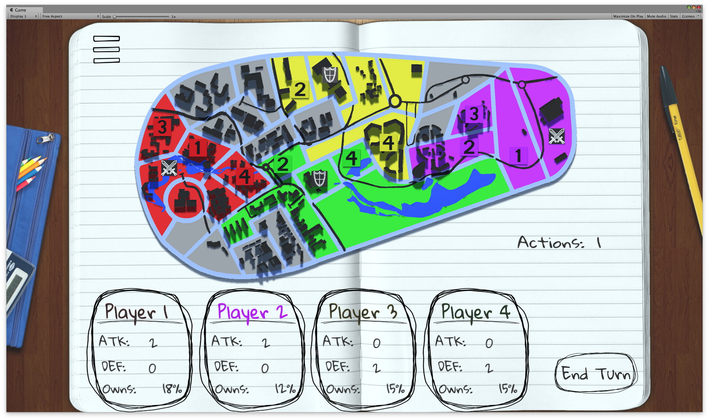

Menu button
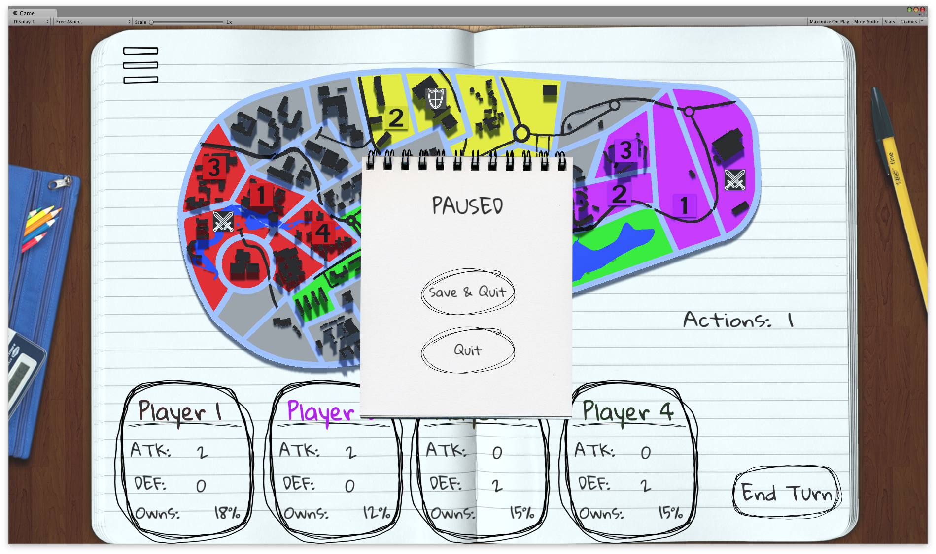
Placed in the top left corner, it is used to access a Pause Menu, which contains two buttons: Save & Quit and Quit. Save & Quit is used to Save the current game to file, so it may be loaded at a later time and then quit to the main menu. Quit just takes the player to the main menu and progress in the current game is lost.
Gameplay

When the game starts, each player owns one landmark and one Level 1 unit which is situated on that landmark. Which player owns which landmark is determined randomly. Players then take turns moving their units and starting conflicts with other players. A player is considered eliminated when they have no units left and they do not own any landmarks. The game ends when all but one player is eliminated, and that player is the winner.

Taking Turns
At the start of a player’s turn, new units are spawned at any landmarks the player owns, assuming that there is not a unit already on the landmark. During their turn, the player may perform up to 2 actions, such as moving one of their units into a sector adjacent to the sector it currently occupies or attacking an enemy.

To move a unit, first select the unit you wish to move by clicking on it, or on the sector it occupies. This will highlight the sectors adjacent to the one the selected unit occupies, indicating the possible sectors it can move into. Click on the sector you would like to move the selected unit into, and the move action will be resolved in one of three ways:

- If you move the unit into an unoccupied sector (i.e. one that does not already contain a unit), then the unit moves into that sector unimpeded. If the sector belonged to a different player prior to the move, the unit captures the sector, and the unit’s level increases by 1 if it is not already at the maximum level (i.e. Level 5).
- If you move the unit into an occupied sector (i.e. one that already contains a unit), and you own the unit occupying the sector, then the two units swap places.
- If you move the unit into an occupied sector, and the unit occupying the sector is owned by a different player, then a conflict occurs. Conflicts are described in more detail in a later section.

A player’s turn ends either after they perform 2 actions or after the End Turn Button is clicked. It is then the next player’s turn.

Conflicts
A conflict occurs when a unit owned by one player (the attacking player) attempts to move into a sector occupied by a unit owned by another player (the defending player). The outcome of a conflict depends on two major factors: the respective levels of the units involved in the conflict and the amount of perks owned by the players involved in the conflict.

Higher-level units are generally stronger than lower-level units. The higher a unit’s level is compared to its opponent, the better its chances are at winning the conflict.

The different types of perks, Attack and Defense, boost a player’s chance to win a conflict depending on if the player is attacking or defending. Having more Attack increases a player’s chance of winning if they are attacking, and having more Defense increases a player’s chance of winning if they are defending.

Although unit levels and resource amounts can stack the odds in favour of one player, the outcome of the conflict is not always certain - even a player at a severe disadvantage in a conflict can be victorious if luck is on their side.

Once a conflict is resolved, the losing unit is destroyed. If the attacking unit was the winner, then it moves into the sector previously occupied by the defending unit. If the defending unit was the winner, it remains in its sector.

Vice Chancellor
A Vice Chancellor hides at the beginning of every game in a randomly selected sector. When such sector is conquered by a player the Vice Chancellor is captured and the player who finds him may play a minigame to try and win a bonus.
After playing the minigame a bonus is always granted to the player and the size of the bonus depends on the player’s performance in the minigame.
Once the Vice Chancellor has been discovered the mini-game cannot be played again.
Minigame

After capturing the Vice Chancellor, the player automatically enters the “Flappy Goose” minigame.

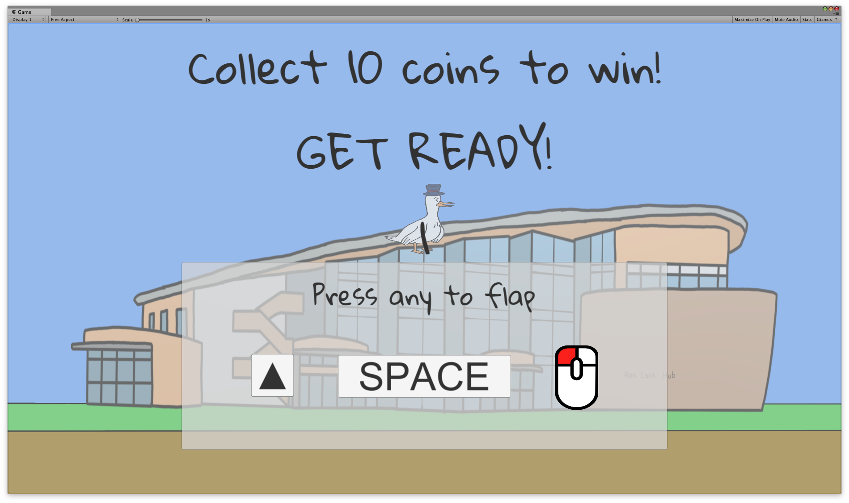
In the minigame the player controls a Goose and has to collect coins by making the goose flap and pass through obstacles. The player has three seconds to get ready to play as a countdown screen shows the objective and the controls to make the bird flap.

The minigame ends whenever the Goose touches the ground or any of the obstacles or if they collect 10 coins.
The number of coins collected determines the bonus received, an image representing the coin is shown on the right.

Successfully collecting 10 coins grants a big bonus of +4 Attack and +4 Defense.
Failing to collect the 10 coins grants a small bonus of +1 Attack and + 1 Defense.

The minigame automatically returns to the game and notifies the player about what bonus they received.

Controls

Main Game
Left Click | Press buttons and perform actions on sectors

Minigame
Left Click | Make the goose flap its wings
Spacebar | Make the goose flap its wings
Up Arrow Key | Make the goose flap its wings

